**j. Mans summer collection**

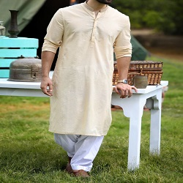

**CREAM POLYESTER VISCOSE KAMEEZ SHALWAR**

PKR6992.00

* Jacquard Shirt: 3.5 Meters
* Trouser: 3.5 Meters

**MORE INFORMATION:**

* color: Cream & white
* Wear Type: Semi-Formal
* Product Category: Semi-Formal Kameez Shalwar
* Volume : Volume 4 2022
* Collection: Festive Affair '22
* Fabric: Washing wear
* Sizes: small , medium , Large
* Disclaimer: Due to the photographic lighting & different screen calibrations, the colors of the original product may slightly vary from the picture